Git Lab Work -2

1.Create a .log file and a log folder in the working directory
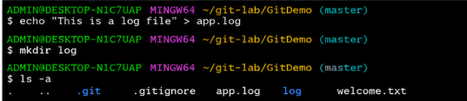

2.Update .gitignore to .ignore log files and log folder
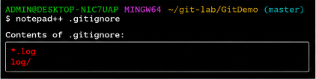

3.Check git status
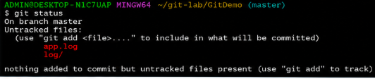

4.Add .gitignore and commit
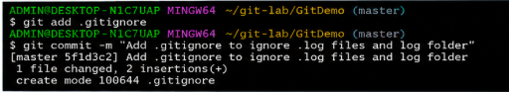

5.Check git status


